**AI SOLUTIONS FOR FARMERS**

## A PROJECT REPORT

***Submitted by,***

**P. Sudharshan Reddy - 20211CSE0073**

**B. Koteswar Reddy - 20211CSE0113**

**Y. Shiva Shankar Reddy - 20211CSE070**

**P. Sailendra - 20211CSE0096**

### ***Under the guidance of,***

**Ms. AYESHA TARANUM**

***in partial fulfillment for the award of the degree of***

**BACHELOR OF TECHNOLOGY**

**IN**

**COMPUTER SCIENCE AND ENGINEERING**

**At**



**PRESIDENCY UNIVERSITY**

**BENGALURU**

**DECEMBER 2024**

**PRESIDENCY UNIVERSITY**

**SCHOOL OF COMPUTER SCIENCE ENGINEERING**

**CERTIFICATE**

This is to certify that the Project Report “**AI Solution for Farmers**” being submitted by “P. Sudharshan Reddy, B. Koteswar Reddy, Y. Shiva Shankar Reddy, P. Sailendra” bearing roll numbers “20211CSE0073, 20211CSE0113, 20211CSE0070, 20211CSE0096” in partial fulfillment of the requirement for the award of the degree of Bachelor of Technology in Computer Science and Engineering is a bonafide work carried out under my supervision.

|  |  |
| --- | --- |
| **Ms. Ayesha Taranum**  Assistant Professor  School of CSE  Presidency University | **Dr . Asif Mohammed**  Associate Professor & HoD  School of CSE  Presidency University |

|  |  |  |
| --- | --- | --- |
| **Dr. L. SHAKKEERA**  Associate Dean  School of CSE  Presidency University | **Dr. MYDHILI NAIR**  Associate Dean  School of CSE  Presidency University | **Dr. SAMEERUDDIN KHAN**  Pro-Vc School of Engineering  Dean -School of CSE&IS  Presidency University |

**PRESIDENCY UNIVERSITY**

**SCHOOL OF COMPUTER SCIENCE ENGINEERING**

**DECLARATION**

We hereby declare that the work, which is being presented in the project report entitled **AI SOLUTIONS FOR FARMERS** in partial fulfillment for the award of Degree of **Bachelor of Technology** in **Computer Science and Engineering**, is a record of our own investigations carried under the guidance of **Ms. Ayesha Taranum, Assistant Professor**, **School of Computer Science Engineering , Presidency University, Bengaluru.**

We have not submitted the matter presented in this report anywhere for the award of any other Degree.

|  |  |  |
| --- | --- | --- |
| **Names** | **Roll Numbers** | **Signatures** |
| P.Sudharshan Reddy | 20211CSE0073 |  |
| B.Koteswar Reddy | 20211CSE0113 |  |
| Y.Shiva Shankar Reddy | 20211CSE0070 |  |
| P.Sailendra | 20211CSE0096 |  |

**ABSTRACT**

India is a nation deeply rooted in agriculture and ranks among the top three global producers of many crops. Despite being central to the agricultural sector, Indian farmers often remain at the lower end of the socio-economic spectrum. A major challenge they face is deciding which crop is most suitable and profitable for their soil. This issue is exacerbated by the diversity of soil types across different geographical regions and the limited access to effective technological solutions.

To address this challenge, this paper proposes a crop recommendation system powered by a machine learning (ML) model. The system analyzes various parameters, such as region, soil type, expected yield, and market selling prices, to recommend the optimal crop to farmers. By leveraging advanced technology, this system aims to empower farmers to make informed decisions and improve their agricultural outcomes.Agriculture is the backbone of India's economy and plays a crucial role in ensuring food security. It contributes significantly to the nation's Gross Domestic Product (GDP) and provides livelihoods for a large segment of the population. However, food production and crop prediction have become increasingly challenging due to unpredictable climatic changes. These changes adversely impact farmers by reducing crop yields and limiting their ability to plan for future cultivation effectively.

Another critical factor affecting agricultural productivity is plant diseases. Diseases in crops are common and can severely impact yield if not addressed promptly. In recent years, advancements in technology have made plant disease detection more feasible, drawing significant attention due to its potential to reduce crop losses in large agricultural fields.

Plant disease detection, particularly in crops like tomatoes, is essential for maintaining crop health and ensuring good production quality. Traditional methods of disease detection rely on manual monitoring by experts, which can be time-consuming and resource-intensive. However, advanced methods, such as image processing and machine learning, have streamlined the process. These techniques help in early identification of diseases, enabling farmers to take preventive measures and reduce the spread of infections.

If diseases are not addressed on time, the plants' growth and production are significantly impacted, leading to reduced agricultural output. By integrating modern technologies into agricultural practices, farmers can monitor their crops more effectively and minimize losses, ultimately improving their economic stability and contributing to sustainable farming practices.

**ACKNOWLEDGEMENT**

First of all, we indebted to the **GOD ALMIGHTY** for giving me an opportunity to excel in our efforts to complete this project on time.

We express our sincere thanks to our respected dean **Dr. Md. Sameeruddin Khan**, Pro-VC, School of Engineering and Dean, School of Computer Science Engineering & Information Science, Presidency University for getting us permission to undergo the project.We express our heartfelt gratitude to our beloved Associate Deans **Dr. Shakkeera L and Dr. Mydhili Nair,** School of Computer Science Engineering, Presidency University, and **Dr. Asif Mohammed**, Head of the Department, School of Computer Science Engineering, Presidency University, for rendering timely help in completing this project successfully.

We are greatly indebted to our guide **Ms. Ayesha Taranum, Assistant Professor** and Reviewer **Dr. JayaChandra**, School of Computer Science Engineering, Presidency University for his/her inspirational guidance, and valuable suggestions and for providing us a chance to express our technical capabilities in every respect for the completion of the project work.

We would like to convey our gratitude and heartfelt thanks to the PIP2001 Capstone Project Coordinators **Dr. Sampath A K, Dr. Abdul Khadar A and Mr. Md Zia Ur Rahman**, department Project Coordinators **Dr. Jayanthi Kamalasekaran, Mr. Amarnath J L** and Git hub coordinator **Mr. Muthuraj.**

We thank our family and friends for the strong support and inspiration they have provided us in bringing out this project.

P Sudharshan Reddy

B Koteswar Reddy

Y Shiva Shankar Reddy

P Sailendra

**LIST OF TABLES**

|  |  |  |
| --- | --- | --- |
| **Sl. NO** | **TABLE CAPTION** | **PAGE NO** |
| 1 | Test cases | 36 |
| 2 | Test case model building | 36 |

**LIST OF FIGURES**

|  |  |  |
| --- | --- | --- |
| **FIGURES** | **DETAILS** | **PAGE NO.** |
| Figure 1 | Support Vector machine | 20 |
| Figure 2 | Work Flow Diagram | 25 |
| Figure 3 | Use Case Diagram | 26 |
| Figure 4 | Class Diagram | 27 |
| Figure 5 | Sequence Diagram | 27 |
| Figure 6 | Collaboration Diagram | 28 |
| Figure 7 | Deployment Diagram | 29 |
| Figure 8 | Component Diagram | 29 |
| Figure 9 | Activity Diagram | 30 |
| Figure 10 | E R Diagram | 31 |
| Figure 11 | DFD Level 1 | 32 |
| Figure 12 | DFD Level 2 | 33 |
| Figure 13 | Home page | 49 |
| Figure 14 | About page | 49 |
| Figure 15 | Soil Prediction | 50 |
| Figure 16 | Output of Soil Prediction | 50 |
| Figure 17 | Crop Prediction | 51 |
| Figure 18 | Output of crop Prediction | 51 |
| Figure 19 | Plant disease prediction | 52 |
| Figure 20 | Output of Plant disease prediction | 52 |

**TABLE OF CONTENTS**

|  |  |  |
| --- | --- | --- |
| **TITLE** | | **PAGE NO.** |
| **ABSTRACT** | | **iv** |
| **LIST OF TABLES** | | **2** |
| **LIST OF FIGURES** | | **20** |
| **CHAPTER I** | **INTRODUCTION** | **1** |
| 1.1 | Background and Motivation 1 | |
| 1.2 | Problem Statement 2 | |
| 1.3 | Objectives of the Project 2 | |
| 1.4 | Scope of the Project 3 | |
| 1.5 | Modules 3 | |
| 1.6 | Project Introduction 5 | |
| **CHAPTER II** | **LITERATURE REVIEW** | **8** |
| 2.1 | Literature Review | 8 |
| 2.2 | Related Works | 10 |
| **CHAPTER III** | **RESEARCH GAPS OF EXISTING METHODS** | **13** |
| 3.1 | Existing System | 13 |
| 3.2 | Functional Requirements | 13 |
| 3.3 | Non-Functional Requirements | 13 |
| 3.4 | Feasibility Study | 14 |
| **CHAPTER IV** | **PROPOSED METHODOLOGY** | **16** |
| 4.1 | Random Forest Classifier | 16 |
| 4.2 | Convolutional Neural Networks | 17 |
| 4.3 | Artificial Neural Networks | 18 |
| 4.4 | Mobile Net | 19 |
| 4.5 | Support Vector Machine | 20 |
| 4.6 | Decision Tree | 21 |
| 4.7 | Logistic Regression | 22 |
| **CHAPTER V** | **OBJECTIVES** | **23** |
| **CHAPTER VI** | **SYSTEM DESIGN AND IMPLEMENTATION** | **25** |
| 6.1 | UML Diagram | 26 |
| 6.1.1 | Use Case Diagram | 26 |
| 6.1.2 | Class Diagram | 27 |
| 6.1.3 | Sequence Diagram | 27 |
| 6.1.4 | Collaboration Diagram | 28 |
| 6.1.5 | Deployment Diagram | 29 |
| 6.1.6 | Component Diagram | 29 |
| 6.1.7 | Activity Diagram | 30 |
| 6.1.8 | E R Diagram | 31 |
| 6.2 | Data Flow Diagram | 32 |
| 6.3 | Technology Stack | 33 |
| 6.3.1 | Programming Languages | 33 |
| 6.3.2 | Tools | 33 |
| 6.4 | Testing | 34 |
| 6.4.1 | Functional Testing | 34 |
| 6.4.2 | White Box Testing | 35 |
| 6.4.3 | Black Box Testing | 35 |
| **CHAPTER VII** | **TIME LINE FOR EXECUTION** | **38** |
| **CHAPTER VII** | **OUTCOMES** | **39** |
| **CHAPTER X** | **RESULTS AND DISCUSSIONS** | **40** |
| **CHAPTER IX** | **CONCLUSION** | **43** |
|  | **REFERENCES** | **44** |
| **Appendix A** | **PSUEDOCODE** | **46** |
| **Appendix B** | **SCREENSHOTS** | **49** |
| **Appendix C** | **ENCLOSURES** | **53** |

**CHAPTER-1**

**INTRODUCTION**

* 1. **Motivation:**

In the age of rapid technological advancements, agriculture is undergoing a transformation that is both exciting and indispensable. With the integration of artificial intelligence (AI) and machine learning (ML) technologies, farmers are now empowered to make data-driven decisions that optimize productivity and sustainability. This convergence of technology and agriculture addresses critical challenges such as soil health, crop management, and plant disease prevention, thereby revolutionizing how we grow food to meet the needs of a growing global population.

One of the most impactful applications of AI in agriculture lies in soil prediction and fertility suggestion. AI-driven models analyze vast datasets, including soil composition, moisture levels, and historical crop yields, to provide farmers with actionable insights. By predicting soil health and recommending appropriate fertilizers or amendments, AI ensures that crops receive the nutrients they need while minimizing overuse of chemicals, which can harm the environment. This precision farming approach helps enhance soil fertility and long-term agricultural sustainability.

Crop prediction is another transformative area where AI excels. Using satellite imagery, weather forecasts, and historical farming data, machine learning algorithms can predict the best time for planting and harvesting. These predictions enable farmers to maximize yields and reduce crop losses caused by unforeseen weather conditions or other external factors. Furthermore, AI systems can identify the most suitable crops for specific regions, considering factors such as climate, soil type, and water availability. This ensures optimal resource utilization and enhances food security.

Plant disease detection, powered by AI, is addressing one of agriculture's most persistent challenges. Early detection of plant diseases is crucial to preventing widespread crop damage and loss. AI-powered tools, such as image recognition systems, analyze photos of plants to identify signs of diseases or pest infestations with remarkable accuracy. Farmers can then take timely action to treat affected plants, reducing the need for broad-spectrum pesticides and lowering costs. This not only improves crop health but also aligns with sustainable agricultural practices by promoting eco-friendly solutions.

The integration of AI solutions in agriculture is ushering in a new era of efficiency and sustainability. By harnessing the power of advanced technologies for soil prediction, crop management, and disease detection, farmers can achieve higher productivity while reducing environmental impact. As the global population continues to grow, the role of AI in agriculture will become increasingly vital, ensuring that we can meet the rising demand for food in a way that preserves our planet for future generations.

**1.2 Problem Statement:**

I. One of the primary challenges in the domains of soil prediction, fertility suggestion, crop prediction, and plant disease detection is the lack of uniformity and integration of data sources. Agriculture relies on multifaceted data such as soil quality, weather patterns, and pest/disease data, which often come from disparate sources and in various formats.

II. Integrating and standardizing this data for comprehensive analysis is a pressing issue. While advanced technologies are transforming agriculture, they are not equally accessible to all farmers, particularly smallholders in developing regions. The problem lies in the scalability of these solutions. Developing cost-effective, scalable, and user-friendly tools that cater to the specific needs of diverse farming communities remains a significant challenge.

III. As precision agriculture technologies evolve, questions concerning their environmental impact and ethical usage come to the forefront. Over-reliance on fertilizers or pesticides based on AI recommendations can have detrimental effects on ecosystems, and concerns about data privacy and security are growing.

* 1. **Objective of the Project:**

This project's primary goal is to demonstrate three distinct AI-driven applications: soil prediction models, crop predictions, and plant disease detection. These tools aim to predict soil fertility (fertile or non-fertile), recommend suitable crops, and detect plant diseases early.

Soil prediction models analyze parameters like pH, nutrients, and moisture to determine soil health. By classifying soil as fertile or non-fertile, these models guide farmers in improving soil quality and selecting appropriate crops. They also provide recommendations for fertilizers or amendments to enhance productivity while promoting sustainability.

Crop prediction models help farmers choose the most suitable crops for their specific regions. These models consider historical yield data, weather patterns, and soil characteristics to optimize planting and harvesting times. This approach maximizes yield and conserves resources like water and fertilizers.

Plant disease detection models leverage image recognition to identify early symptoms of diseases. By analysing images of leaves or stems, these systems can detect infections with high accuracy. Early detection enables timely interventions, reducing crop losses and the need for excessive pesticide use. This fosters healthier crops and supports eco-friendly farming practices.

By combining soil prediction, crop recommendations, and plant disease detection, this project highlights the transformative potential of AI in agriculture. These innovations empower farmers to make informed decisions, increase efficiency, and reduce environmental impact. As climate change and population growth challenge global food systems, AI-driven solutions will play a vital role in ensuring sustainable agriculture and food security for future generations.

* 1. **Scope:**

The scope of projects related to soil prediction and fertility suggestion, crop prediction, and plant disease detection in agriculture is vast and multifaceted. These projects are designed to address several key aspects within the agricultural domain.

**1.5 Modules:**

**1. User Functionalities**

**1.1 View Home Page:**

When users log in or access the application, they are directed to the home page, which serves as the main hub for all available features and functionalities.

**1.2 View About Page:**

Users can visit the "About" page to learn more about the platform, its goals, and the team responsible for its development.

**1.3 Input Model:**

Users are prompted to input relevant data and parameters required by the model. This data may include information such as soil conditions, crop types, planting schedules, or even images of crops exhibiting symptoms of plant diseases.

**1.4 View Results:**

Once users submit the necessary data, they can view the results generated by the model. These results may include recommendations for soil health improvement, predictions of crop yields, or a diagnosis of plant diseases.

**1.5 Create Dataset:**

For plant disease detection, users can create a custom dataset by uploading images of plants. They can label these images as either healthy or infected. The dataset is then organized into training and testing subsets for model development.

**1.6 Pre-processing:**

To prepare the image dataset for training, users can apply pre-processing techniques, such as resizing or reshaping images, to ensure compatibility with the model requirements.

**1.7 Training:**

The training functionality allows users to train the model using advanced machine learning or deep learning algorithms, such as ResNet50. The system uses the pre-processed dataset to create accurate and reliable predictive models.

**1.8 Classification:**

The results of the classification process are presented to the user, indicating whether the plants are healthy or showing signs of specific diseases.

**2. System Functionalities**

**2.1 Working on Dataset:**

The system processes the uploaded datasets to organize and label images of plants as healthy or infected. This ensures the dataset is prepared for effective model training and evaluation.

**2.2 Pre-processing:**

The system automatically applies pre-processing techniques, including resizing and reshaping images, to ensure they are in the appropriate format for model training.

**2.3 Training the Data:**

The system divides the dataset into training and testing subsets, a crucial step for evaluating the model's performance and accuracy during development.

**2.4 Model Building:**

The system trains the machine learning or deep learning models (e.g., ResNet50) using the pre-processed data, enabling the development of robust and precise prediction models.

**2.5 Generate Results:**

After training is complete, the system generates outputs based on user inputs. These outputs may include disease detection results, soil health recommendations, or predictions about crop yield.

**2.6 Upload Image:**

Users can upload images of plants for analysis. The system processes these images and uses the trained model to classify them as healthy or infected.

**2.7 View Results:**

The system displays the classification results to the user, including images and their respective disease labels or health status.

**1.6 Project Introduction:**

Agriculture has always been a cornerstone of the Indian economy, supporting nearly two-thirds of the population by providing livelihoods and contributing approximately 20% to India’s GDP. At the heart of this sector are farmers, often referred to as "Anna Datta’s" or food providers, who face several challenges. One major issue is the diversity of soil types across regions, making it difficult for farmers to choose crops that are both suitable and profitable for their soil and climatic conditions, leading to frequent financial losses. Additionally, unpredictable weather patterns make it challenging to forecast crop yields and potential profits accurately. Another critical problem is the dismally low returns that farmers earn due to the involvement of multiple intermediaries in the supply chain, which significantly reduces their profit margins. The integration of Machine Learning (ML) and Artificial Intelligence (AI) into agriculture can address these challenges by offering innovative solutions such as precision farming, crop recommendation systems, yield prediction, pest detection, and monitoring farm nutrition levels. AI-driven systems can revolutionize the agricultural sector, providing much-needed support to farmers and ensuring better productivity and profitability. India’s agriculture sector, while contributing significantly to employment and high-value crop production, is still plagued by inefficiencies. Smallholding farmers, who manage less than five acres of land and account for half of the agricultural output, face limited access to modern market systems and institutional credit due to a lack of collateral and low literacy rates. This paper proposes a solution involving a soil analysis and crop prediction mechanism powered by a Convolutional Neural Network and Random Forest Algorithm, aimed at mitigating these issues and increasing profitability for farmers. Furthermore, it introduces a website designed to connect farmers directly with buyers, eliminating the need for intermediaries. This initiative seeks to empower farmers with smart, user-friendly tools that enhance crop yield predictions, optimize resource use, and provide accurate information for better decision-making, ultimately ensuring sustainable growth in the agricultural sector.

The automated identification of plant diseases based on plant leaves represents a transformative breakthrough in the field of agriculture. Early and accurate detection of plant diseases is essential to ensuring optimal crop yield and quality, as it allows farmers to take timely actions to mitigate potential losses. This is particularly important in regions where agriculture forms the backbone of the economy and food security. However, identifying plant diseases remains a challenging task, even for skilled agriculturists and pathologists. The difficulty arises from the sheer variety of crop species and the numerous diseases affecting them, many of which exhibit overlapping symptoms. In rural and remote areas of developing countries, visual observation of disease-affected leaves continues to be the primary method for diagnosis. This approach is time-intensive and subjective, often requiring expert knowledge and continuous monitoring to ensure accuracy. Unfortunately, in many cases, farmers may need to travel long distances to seek expert consultation, incurring significant costs and delays that can further exacerbate the impact of diseases on crops.

To address these challenges, automated computational systems have emerged as a promising solution, offering high precision and throughput for the detection and diagnosis of plant diseases. Such systems can greatly benefit farmers and agronomists by minimizing reliance on human expertise and enabling rapid decision-making. By leveraging advancements in machine learning (ML) and artificial intelligence (AI), researchers have developed models capable of identifying plant diseases with remarkable accuracy. Among these, supervised learning techniques have been widely adopted, relying on labelled datasets of diseased and healthy plant leaves. However, the effectiveness of these models depends heavily on the quality of feature extraction. Feature sets used in machine learning can be broadly categorized into traditional handcrafted features and deep-learning (DL)-based features. Traditional methods typically focus on shape, texture, and color patterns, whereas DL-based approaches rely on convolutional neural networks (CNNs) to automatically learn features directly from raw images.

Pre-processing techniques are critical to the success of automated systems, as they enhance image quality and prepare data for feature extraction. Common pre-processing steps include image enhancement to improve contrast, color transformation to standardize color spaces, and segmentation to isolate diseased areas from the background. Once pre-processed, feature extraction algorithms analyze key attributes of the image, such as pixel intensity, texture uniformity, and edge sharpness. These features are then fed into classifiers like support vector machines (SVM), random forests, or neural networks for disease prediction.

Despite the significant progress made, there are still challenges to overcome. The diversity of plant species and disease symptoms necessitates the development of robust and generalizable models capable of handling variations in environmental conditions, lighting, and image quality. Addressing these challenges requires collaborative efforts to create comprehensive datasets, design novel algorithms, and integrate domain-specific knowledge into computational models. Additionally, deploying these systems in resource-constrained rural areas demands lightweight, low-cost, and user-friendly solutions. With continued research and technological innovation, automated plant disease detection systems hold immense potential to revolutionize agriculture and improve the livelihoods of farmers worldwide.

**CHAPTER-2**

**LITERATURE SURVEY**

**2.1 Literature Review**

**[1] S. Chowdhury, M. Rahman, T. Ahmed, “Deep Learning-Based Segmentation and Classification for Tomato Leaf Diseases *Frontiers in Plant Science*, 2022**

This study explores the use of deep learning techniques to detect diseases in tomato plants at an early stage. The research employs the U-Net model for segmenting diseased areas in leaf images and the Inception Net architecture for disease classification. To boost model performance and generalization, data augmentation methods such as rotation and scaling were applied. The model was tested on well-known datasets, such as Plant Village, achieving high accuracy in both segmentation and classification tasks. Emphasis was placed on preprocessing to enhance image quality and minimize noise, leading to a more effective solution for agricultural challenges. The results suggest that this model has significant potential for practical use in farming, where it could assist in the early identification of diseases and improve crop management

**[2] . R. Das, S. Patel, P. Singh, “Hybrid Deep Learning Approach Using Attention-Based Dilated CNN” *MDPI Journal of Agriculture Informatics*, 2022**

This study explores plant disease detection using deep convolutional neural networks (CNNs), focusing on tomato leaf diseases. It utilizes U-Net for segmentation and Inception Net for disease classification, enhanced by data augmentation techniques like rotation, scaling, and translation to improve model diversity and generalization. The research emphasizes CNNs' ability to manage noisy data and prevent overfitting. A hybrid approach integrates attention mechanisms with dilated CNNs, further improving classification accuracy. To balance datasets, Generative Adversarial Networks (GANs) are employed. Preprocessing steps like filtering and segmentation ensure effective feature extraction, leading to high classification accuracy and robust performance, making the system valuable for early disease detection, optimized pesticide use, and improved crop yields in precision farming.

**[3]"Soil Classification and Crop Suggestion Using Deep Learning," Journal of Agricultural Engineering, vol. 8, issue 7, pp. 1625-1628, Jul 2023**

The study highlights the use of Convolutional Neural Networks (CNNs) to improve agricultural practices by accurately classifying soil types and suggesting crops suitable for specific soil conditions. By analysing soil characteristics such as texture, composition, and organic content, the model provides precise predictions for optimizing crop growth. The research utilized a dataset consisting of soil images and applied data augmentation techniques, including image rotation, flipping, and scaling, to enhance model robustness and prevent overfitting. These strategies expanded the dataset and ensured reliable performance when encountering new data. Unlike traditional soil classification methods, which often require labour-intensive laboratory analyses, this deep learning approach streamlines the process, making it both time-efficient and accessible for various farming scales.

The CNN model demonstrated high accuracy in identifying soil categories and offered crop suggestions tailored to the soil’s unique properties, such as water retention, nutrient levels, and pH balance. This integration of deep learning not only boosts agricultural productivity but also promotes sustainable farming by guiding crop selection based on soil suitability. The study also tackled challenges like imbalanced data and model generalization, employing advanced techniques to ensure consistent performance across diverse soil types. By automating soil analysis and crop recommendation, this innovative system reduces manual effort while supporting data-driven, precise agricultural decisions, benefiting both smallholder and large-scale farmers. The findings underscore the transformative potential of deep learning in modern agriculture, contributing to sustainability and improved crop management strategies.

**[4]. “Plant-Based Disease Detection with deep Learning" Front. Plant Sci., 21 March 2023**

The recent advancements in crop disease detection using deep learning have revolutionized agricultural practices. A comprehensive survey on this topic from 2023 explores various approaches to image-based plant disease detection, highlighting the growing importance of deep learning techniques such as Convolutional Neural Networks (CNNs) and other state-of-the-art methods. The study emphasizes how these technologies have significantly outperformed traditional methods in terms of accuracy and speed. CNNs, in particular, have been pivotal in automating the identification and classification of diseases in plants through images. The survey also touches on several challenges and opportunities within the field. For instance, while large and diverse datasets are crucial for training deep learning models, the availability of such datasets remains limited. Additionally, the paper discusses the potential of transfer learning to improve model accuracy, especially when the training data is scarce. Several notable datasets used in plant disease research, such as the Plant Village dataset, have been instrumental in developing these models. However, the survey highlights that even with high-quality datasets, preprocessing techniques and the diversity of plant species need to be addressed to enhance the robustness of these models.

**2.2 Related Works**

The Random Forest Classifier and AdaBoost are powerful machine learning techniques frequently used in soil fertility prediction and agricultural management projects. The Random Forest Classifier operates as an ensemble learning method that builds multiple decision trees during training and outputs the mode of the classes (classification) or mean prediction (regression) of the individual trees. It is particularly effective in handling large datasets with high dimensionality and capturing the complex, nonlinear relationships between soil properties such as nutrient levels, pH, and organic matter. Random Forest excels in avoiding overfitting by averaging predictions across trees and using random feature selection, making it robust and reliable for predicting soil fertility, AdaBoost, or Adaptive Boosting, is another ensemble technique that combines multiple weak classifiers iteratively to form a strong classifier. In soil fertility prediction, AdaBoost adjusts the weights of misclassified data points in successive iterations, ensuring the model focuses on challenging cases. This approach enhances the accuracy of predictions by emphasizing critical features of soil data and addressing noise or outliers in datasets. AdaBoost works well in scenarios requiring precise classification of soil fertility levels, often achieving higher accuracy compared to standalone models. When used together, Random Forest and AdaBoost complement each other by leveraging their respective strengths—Random Forest provides robustness and handles feature interactions effectively, while AdaBoost ensures iterative improvement in model performance. Their integration into soil fertility prediction projects allows for scalable, accurate, and efficient modeling, offering actionable insights for optimizing farming practices and enhancing agricultural productivity.[5]

The integration of Artificial Neural Networks (ANN), Random Forest, and K-Nearest Neighbor (KNN) classifiers has shown great potential in agricultural applications, particularly for crop and soil management. ANN is a versatile algorithm that mimics human brain function to detect patterns and relationships in data. It is highly effective for large datasets, leveraging its multilayer structure to handle non-linear relationships, such as those between soil nutrients and crop yields. ANN can predict outcomes like crop health or yield with high accuracy by continuously improving through backpropagation. The Random Forest classifier is an ensemble learning method that builds multiple decision trees and averages their results to enhance accuracy and prevent overfitting. It is particularly suitable for analyzing agricultural data, such as nutrient levels, temperature, and soil pH, offering robust predictions for crop selection and soil fertility classification. By using features like temperature, humidity, and rainfall, Random Forest excels at determining optimal conditions for specific crops, supporting precise and scalable decision-making. The K-Nearest Neighbor (KNN) algorithm, known for its simplicity, classifies data points based on the nearest labeled data in feature space. In agriculture, KNN is often applied to group crops or predict crop types based on soil and environmental parameters. It is effective for datasets with clear clusters, such as distinguishing crops based on nutrient profiles or environmental needs. Combining these algorithms allows leveraging their strengths: ANN's adaptability, Random Forest's robustness, and KNN's ease of use. Together, they form a comprehensive approach to agricultural data modeling, enabling precise crop prediction, soil fertility assessment, and sustainable farming practices. These techniques, when implemented in agricultural projects, can optimize resource use, improve crop yields, and support informed decision-making for farmers.[8]

The use of Machine Learning (ML) and Deep Learning (DL), particularly through techniques like image processing and Convolutional Neural Networks (CNNs), has significantly advanced the field of plant disease detection. These technologies enable accurate and efficient identification of plant diseases by analyzing visual data, such as leaf images, to differentiate between healthy and diseased plants. CNNs excel in feature extraction and pattern recognition from images, making them ideal for processing complex datasets and identifying subtle disease symptoms. By automating disease detection, ML and DL overcome the challenges of manual methods, which are often time-consuming, error-prone, and unreliable. These advancements are particularly useful for large-scale agriculture, where early and precise detection can prevent the spread of diseases and minimize crop losses. The integration of ML and DL ensures scalability, allowing farmers and agricultural professionals to monitor crop health efficiently. Despite challenges like data availability and imaging quality, these methods offer solutions by leveraging large datasets and enhancing image preprocessing techniques. This makes them invaluable for improving global food security, optimizing agricultural productivity, and reducing dependency on manual labor for disease diagnosis.[10]

In India's economy, which is heavily dependent on agriculture and agro-industry, optimizing crop yield is essential for improving food production and economic growth. To achieve this, machine learning (ML) techniques are increasingly being utilized in crop yield estimation, providing precise predictions based on environmental datasets. These ML models learn from various data sources, such as soil quality, climate conditions, and historical crop performance, to predict future yields. The results from these models help farmers take corrective measures to optimize yields and improve agricultural productivity. Additionally, crop recommendations generated by these models suggest the most suitable crops for a specific region based on soil and environmental factors. This integration of machine learning in agricultural practices enhances the overall efficiency and sustainability of farming, promoting higher yields and healthier crops.[19]

**CHAPTER-3**

**RESEARCH GAPS OF EXISTING METHODS**

**3.1 Existing System**

The field of machine learning has seen significant growth, with techniques broadly categorized into traditional methods and modern machine learning approaches. This section focuses on related work in areas such as soil prediction and fertility analysis, crop prediction, and plant disease detection, highlighting how machine learning and deep learning outperform traditional methodologies. In the existing system, algorithms like Artificial Neural Networks (ANN), Support Vector Machines (SVM), and Multilayer Perceptron (MLP) are employed for model development. However, these methods often demand substantial memory and may not deliver highly accurate results, which limits their overall effectiveness.

**3.2 Functional Requirements:** Functional requirements represent the essential capabilities and features that the system must provide to fulfil user needs. These requirements define the input, the operations to be executed, and the expected output. They form the foundation of the system and must be clearly defined and implemented as part of the development process. Functional requirements are the core functionalities visible to the user in the final product. Examples include:

1) Ensuring the system verifies the identity of users each time they log in.

2) Automatically shutting down the system in the event of a cyber-attack to protect sensitive data.

**3.3 Non-functional requirements:** Non-functional requirements are the quality standards and constraints the system must meet as specified in the project agreement. These requirements are essential for ensuring the system’s overall usability, reliability, and performance. Unlike functional requirements, they are not directly observable in the system's behavior but contribute to its effectiveness. Key aspects of non-functional requirements include:

**• Portability**

Portability refers to a system's or software's ability to function across different platforms, environments, or devices with minimal modification. For example, a portable application can run seamlessly on Windows, macOS, and Linux. High portability ensures flexibility and reduces the effort required for adaptation.

**• Security**

Security focuses on protecting a system or software from unauthorized access, breaches, or attacks. It includes safeguarding data integrity, confidentiality, and availability. Security mechanisms, such as encryption, firewalls, and authentication protocols, are essential to prevent vulnerabilities.

**• Maintainability**

Maintainability refers to the ease with which a system or application can be updated, improved, or fixed over time. High maintainability ensures that developers can quickly adapt the system to meet changing requirements, fix bugs, or add new features. It often involves clean, modular code and comprehensive documentation.

**• Reliability**

Reliability is the ability of a system or application to perform its intended functions consistently and without failure over time. A reliable system can handle errors gracefully and recover from failures, ensuring that it remains operational even under stress or unforeseen circumstances.

**• Scalability**

Scalability refers to a system's ability to handle increased load or demand without compromising overall performance. A scalable application can accommodate growing numbers of users, data, or transactions by efficiently utilizing resources like processing power, memory, and storage. Scalability is crucial for systems expected to grow over time.

**3.4 Feasibility Study**

The feasibility of the project is evaluated in this phase, where a business proposal is presented along with a general plan for the project and some cost estimates. During system analysis, the feasibility study ensures that the proposed system does not pose a burden on the organization. To carry out a proper feasibility analysis, it is important to understand the key requirements for the system.

Three main considerations in the feasibility analysis are:

* Economical Feasibility
* Technical Feasibility
* Social Feasibility

**Economical Feasibility**

This study is conducted to assess the economic impact of the proposed system on the organization. The company has a limited budget for research and development, so the expenditures must be justified. The system is developed within budget constraints by utilizing freely available technologies, with only the customized products requiring purchase.

**Technical Feasibility**

The technical feasibility study focuses on evaluating the technical requirements of the system. The system must not place high demands on the available technical resources. If the system requires substantial resources, it could create excessive strain on the client. The developed system should have minimal requirements, allowing for easy implementation with few or no changes to existing infrastructure.

**Social Feasibility**

This study assesses the level of user acceptance of the system. It includes user training to ensure efficient use of the system. Users must not feel threatened by the system; instead, they should view it as a valuable tool. The acceptance level depends on the training and education methods employed to familiarize users with the system. By increasing their confidence, users can offer constructive feedback, which is essential as they are the final users of the system.

**CHAPTER-4**

**PROPOSED MOTHODOLOGY**

**4.1 Random Forest:**

The Random Forest algorithm is a powerful machine learning technique commonly used for both classification and regression tasks, making it a highly versatile tool in various fields, including agriculture. It is an ensemble method that combines multiple decision trees to create a stronger and more reliable model. In Random Forest, each tree is built using a random subset of the data, and a random subset of features is selected to split the data at each node during training. This randomness ensures that each tree in the forest is distinct, and the overall model is less likely to overfit the training data. When making predictions, Random Forest aggregates the outputs from all individual trees, either by majority voting for classification tasks or averaging the outputs for regression tasks. This process enhances the model's accuracy and ability to generalize.

One of the primary advantages of Random Forest is its ability to handle complex, high-dimensional data efficiently. By combining multiple decision trees, it can capture non-linear relationships and interactions between features that simpler models may miss. Additionally, Random Forest is highly resistant to overfitting, making it particularly effective when working with noisy or imbalanced datasets. The algorithm's robustness allows it to maintain high accuracy even in cases where the data is incomplete or contains missing values, which is common in real-world applications.

In the agricultural sector, Random Forest has proven to be invaluable in a variety of tasks. For instance, it is widely used for crop yield prediction, where it analyzes historical data, weather conditions, soil characteristics, and other environmental factors to forecast future crop yields. This enables farmers to plan more effectively, optimize resource use, and maximize production. Furthermore, Random Forest is also applied in soil quality assessment, where it evaluates the health and fertility of soil based on parameters such as pH levels, organic matter content, and nutrient levels. This information helps farmers make informed decisions regarding soil management, including fertilizer application and crop selection.

Random Forest is an effective tool in plant disease detection, where it can identify patterns in plant images or sensor data to detect early signs of diseases. By recognizing subtle changes in plant health, Random Forest models can alert farmers to potential problems before they become widespread, reducing crop losses and improving overall farm productivity. In fertilizer recommendations, the algorithm can recommend the optimal amount and type of fertilizers based on the specific nutrient deficiencies identified in the soil, thereby reducing the risk of over-fertilization or under-fertilization. In addition to its practical applications, another advantage of Random Forest is its interpretability. While deep learning models can often be seen as "black boxes," Random Forest provides insight into feature importance, showing which variables (such as rainfall, temperature, or soil nutrients) have the most significant impact on predictions. This feature allows farmers and agricultural experts to better understand the underlying dynamics of their farming systems and make more data-driven decisions. Overall, Random wooded area is a powerful and flexible algorithm that plays a essential role in current agriculture, assisting to optimize farming practices, decorate crop yields, and promote sustainable agricultural growth.

**4.2** **Convolutional Neural Networks (CNN):**

Convolutional Neural Networks (CNNs) are a specialized form of deep learning algorithm frequently used for analyzing visible data. they may be especially effective in responsibilities which includes photo reputation, object detection, and photograph type, due to their capacity to automatically detect and learn patterns in pixel data. A CNN typically consists of several layers: the convolutional layers, where the network applies various filters (also called kernels) to the input image to detect features like edges, textures, and shapes; the pooling layers, which reduce the spatial dimensions of the data and help to make the model more computationally efficient; and the fully connected layers, where the high-level features detected by the convolutional layers are used to make final predictions or classifications. This ability to learn spatial hierarchies makes CNNs particularly well-suited for tasks involving visual inputs, such as image segmentation, object detection, and even time-series data represented visually. In agriculture, CNNs have found numerous applications, particularly in plant disease detection and crop monitoring. For instance, CNNs can be used to analyze images of crops taken through cameras or enabling the identification of early signs of diseases or pest infestations. By training a CNN model on a large, labeled dataset (for example, distinguishing between healthy and diseased plants), the network learns to detect even subtle visual differences, such as changes in leaf texture, color, or shape that indicate the presence of a disease. This allows for rapid and accurate detection, enabling farmers to take prompt action and minimize crop damage. CNNs are also used for weed detection in precision agriculture. By analyzing images of fields, CNN models can distinguish between crops and weeds, helping to automate weeding processes and reduce the need for herbicides. This application promotes more sustainable farming practices by enabling selective weed removal without harming the crops. Furthermore, CNNs can also assist in yield prediction by analyzing images of plant growth over time, which can be correlated with various environmental factors to estimate the likely yield of a crop. The strength of CNNs in handling visual data has also led to their use in remote sensing applications, such as analyzing satellite or drone imagery to assess soil health, crop conditions, and overall farm productivity. These models can identify patterns and anomalies that may be invisible to the human eye, helping farmers make better decisions regarding irrigation, fertilization, and harvest timing. Moreover, CNNs can be integrated with other machine learning models, such as Random Forests or Support Vector Machines (SVMs), to enhance prediction accuracy and offer more comprehensive insights into agricultural processes. CNNs offer a powerful tool for addressing a wide range of challenges in modern agriculture. By automating visual analysis tasks like disease detection, crop monitoring, and field assessment, CNNs contribute to more efficient, sustainable, and data-driven farming practices. Their ability to process large amounts of visual data quickly and accurately enables farmers to make informed decisions, ultimately leading to improved crop yields and better resource management.

**4.3 Artificial Neural Networks (ANN):**

Artificial Neural Networks (ANNs) are widely used in image recognition, a task that involves analyzing and classifying visual data. ANNs, particularly Convolutional Neural Networks (CNNs), are highly effective for image-related tasks as they automatically learn to identify patterns, edges, textures, and other features in images. CNNs work by applying filters to images in convolutional layers, detecting simple features in early layers and combining them into more complex patterns in deeper layers. In agriculture, ANNs are used for crop disease detection by analyzing images of plants. The network can identify early signs of diseases, pests, or nutrient deficiencies by recognizing visual anomalies such as discoloration, spots, or changes in texture. By training on large datasets of labeled plant images (healthy vs. diseased), the ANN can automatically distinguish between different conditions, helping farmers take timely actions to protect their crops. ANNs are used in detection, where they can differentiate between crops and weeds in field images, assisting in automated weeding systems. This reduces the use of herbicides, promoting more sustainable farming practices. Additionally, ANN models applied to satellite or drone imagery can assess crop health, identifying areas that may require attention, like irrigation or fertilization. ANNs for image recognition in agriculture streamline tasks like disease and pest detection, crop monitoring, and precision farming, enabling farmers to make more accurate, data-driven decisions.

**4.4 Mobile Net:**

mobile Net is a highly efficient deep learning architecture, specifically designed for mobile and edge devices, where computational resources such as memory, storage, and processing power are limited. Developed by Google, Mobile Net is part of a family of lightweight models that aim to provide real-time performance without compromising accuracy, making it ideal for applications in environments like smartphones, drones, and other embedded systems. The core innovation behind mobile Net is the depthwise separable convolutions, a method that breaks down the traditional convolution process into two more efficient components. The first step, depthwise convolution, applies an individual filter to each input channel, while the second step, pointwise convolution, merges the results of these individual convolutions. This approach significantly cuts down the number of parameters and computational demands, resulting in faster processing times and a more compact model, making it ideal for on-device applications. MobileNet excels in tasks such as image classification, object detection, and semantic segmentation, where quick and accurate predictions are required. It is designed to work well with real-time applications like augmented reality (AR), facial recognition, and gesture detection, all of which require low-latency processing on mobile devices. The model comes in various versions (e.g., MobileNetV1, V2, V3), each improving upon the previous one in terms of speed, accuracy, and efficiency. MobileNetV2 introduced the inverted residuals and linear bottleneck layers, further optimizing the architecture for mobile devices by reducing complexity without sacrificing performance. MobileNetV3, the latest version, incorporates auto ML and network pruning techniques to achieve even better trade-offs between efficiency and accuracy. Mobile Net’s ability to be easily adapted to specific tasks makes it versatile for a range of applications. It can be fine-tuned on various datasets for tasks like plant disease detection, facial recognition, and even speech recognition. Its small size and efficiency make it especially suitable for on-device AI, where the model runs directly on the user's device without the need for cloud-based processing, ensuring faster response times and greater privacy. Overall, MobileNet provides an excellent solution for deploying deep learning models in resource-constrained environments, pushing the boundaries of edge AI and enabling powerful, real-time, and privacy-preserving applications across industries.

**4.5 Support Vector Machine:**

Support Vector Machine (SVM) is a well-known supervised learning algorithm that is primarily used for classification tasks, though it can also be applied to regression problems. The main objective of SVM is to identify the optimal decision boundary, or hyperplane, that separates data points into different classes in an n-dimensional space. This enables effective classification of new data points based on which side of the hyperplane they fall on. In the process of constructing this hyperplane, SVM identifies key data points known as support vectors, which are located closest to the hyperplane. These support vectors play a crucial role in determining the placement of the hyperplane, ensuring that the separation between classes is as distinct as possible. By leveraging these support vectors, SVM constructs a decision boundary that facilitates accurate classification, even when the dataset is complex or nonlinear. Essentially, SVM works by identifying the hyperplane that best divides the data into separate categories. This strategy ensures that future data points can be categorized correctly, depending on their position relative to the decision boundary.

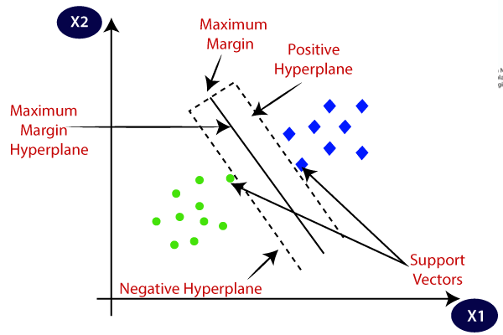

Figure 1: support vector machine

**SVM can be of two types:**

* **Linear SVM**: This type of SVM is used for datasets that are linearly separable, meaning the data can be classified into two distinct classes using a single straight line. When the data can be separated by such a line, a Linear SVM classifier is employed.
* **Non-linear SVM**: Non-linear SVM is used when the data is not linearly separable, meaning it cannot be divided using a straight line. In such cases, a Non-linear SVM classifier is applied to handle the complexity of separating the data into different classes.
* The goal is to find the best decision boundary, called the hyperplane, to separate data points in an n-dimensional space. The hyperplane's dimension depends on the number of features in the dataset: it’s a line for two features and a plane for three features. This optimal boundary ensures effective classification of the data.

**4.6 Decision Tree:**

A decision tree is a widely used tool in machine learning for both classification and regression tasks. It visually represents decisions and their possible consequences, helping to model decision-making processes. The structure of a decision tree resembles an inverted tree with the root at the top. Each internal node represents a decision condition, and the branches represent possible outcomes or decisions based on that condition. The leaves of the tree represent the final decision or classification.

For example, in a classification task like predicting whether a passenger survived or died, the decision tree will split based on features such as age, class, or fare, with each branch leading to a final decision. The end of each branch represents a classification outcome, such as 'survived' or 'died'. This decision tree structure is also used in regression tasks, where it predicts continuous values like house prices.

The decision tree algorithm, commonly referred to as **CART** (Classification and Regression Trees), simplifies the process of data analysis by clearly showing the importance of different features and making the relationships between data points easy to understand.

**4.7 Logistic regression:**

It is a widely-used statistical model designed for binary classification problems where the outcome is categorical, often taking values such as "yes/no," "pass/fail," or "spam/not spam." Unlike linear regression, which predicts continuous values, logistic regression maps predictions to a probability between 0 and 1 using a logistic (sigmoid) function. This ensures that the output remains bounded, making it more appropriate for classification tasks.

The logistic regression model estimates the probability of an event occurring based on a set of input features. For example, in a healthcare scenario, logistic regression could be used to predict whether a tumour is malignant or benign based on medical data, with the result interpreted as the probability of malignancy. This probabilistic approach is particularly useful in fields such as marketing, finance, and healthcare.

One of the key advantages of logistic regression is its simplicity and interpretability. The model generates coefficients that represent the relationship between each feature and the outcome, which can be interpreted as the log-odds of the outcome happening given the feature.

**CHAPTER-5**

**OBJECTIVES**

**1. Support Decision-Making with Predictive Analytics:**

Predictive analytics is a transformative tool for supporting decision-making in crop production by leveraging data-driven insights. By analysing historical crop performance, soil quality, pest patterns, and nutrient requirements, predictive models can estimate future yields with precision. These tools help farmers determine the most suitable crops for a particular field, ensuring optimal resource utilization and sustainability. Additionally, predictive analytics aids in planning crop rotation strategies to maintain soil fertility and prevent degradation. It can also optimize the use of fertilizers and pesticides by suggesting appropriate quantities and timing, minimizing costs while preserving soil health.

Farmers can use these insights to allocate resources equipment more effectively, enhancing operational efficiency. Predictive models also help in identifying potential risks, such as pest infestations or nutrient deficiencies, allowing proactive interventions. Moreover, the technology facilitates the evaluation of market trends, enabling farmers to choose crops that align with demand and maximize profitability. By integrating advanced analytics into agricultural practices, farmers can transition from reactive to proactive management, improving productivity and ensuring long-term sustainability. This empowers farmers with actionable insights, reducing uncertainty and enhancing decision-making at every stage of crop production.

**2. Plant Disease Detection**

Plant disease detection using mobile image processing is an innovative approach that helps farmers identify crop diseases quickly and efficiently. By capturing images of plant leaves, stems, or fruits using a smartphone, farmers can analyze them for signs of disease. The process involves mobile apps powered by artificial intelligence (AI) and machine learning (ML) algorithms trained to recognize patterns, discolorations, or lesions caused by specific diseases.

Once an image is uploaded, the app processes it and compares it to a database of known diseases. It then provides a diagnosis, often accompanied by suggestions for treatment or preventive measures. This eliminates the need for farmers to rely solely on visual inspections or wait for expert opinions, saving time and reducing crop losses.

These apps are user-friendly and do not require advanced technical knowledge. Many can work offline after downloading the necessary databases, making them accessible in remote areas. They also help in tracking disease patterns across fields and seasons, aiding in early detection and proactive management.

By integrating mobile image processing, farmers can respond to plant health issues promptly, reduce pesticide misuse, and improve yields. This technology offers a cost-effective, scalable solution to one of the most critical challenges in modern agriculture.

**3. Crop Prediction:**

Crop prediction based on soil type is a crucial aspect of modern precision agriculture. Different crops have specific soil requirements, such as texture, pH, organic matter content, and nutrient availability. By analyzing these soil characteristics, farmers can determine which crops are best suited for a particular plot of land, ensuring optimal growth and higher yields.

The process begins with soil testing, where samples for properties like nutrient levels (e.g., nitrogen, phosphorus, potassium), water-holding capacity, and salinity. Once this data is collected, predictive models powered by artificial intelligence (AI) or machine learning (ML) can analyze it alongside historical crop performance in similar soil types. These models suggest the most viable crops for cultivation and may also recommend ways to improve soil fertility for better outcomes.

Crop prediction using soil type helps farmers make informed decisions, reducing the risk of crop failure and unnecessary input costs. For example, sandy soils may be better for crops like peanuts or watermelon, while clay-rich soils are ideal for rice or wheat. Additionally, this approach enables sustainable farming by preventing soil degradation and optimizing resource use, contributing to long-term agricultural productivity.

**CHAPTER-6**

**SYSTEM DESIGN & IMPLEMENTATION**

**Work Flow of Proposed System**

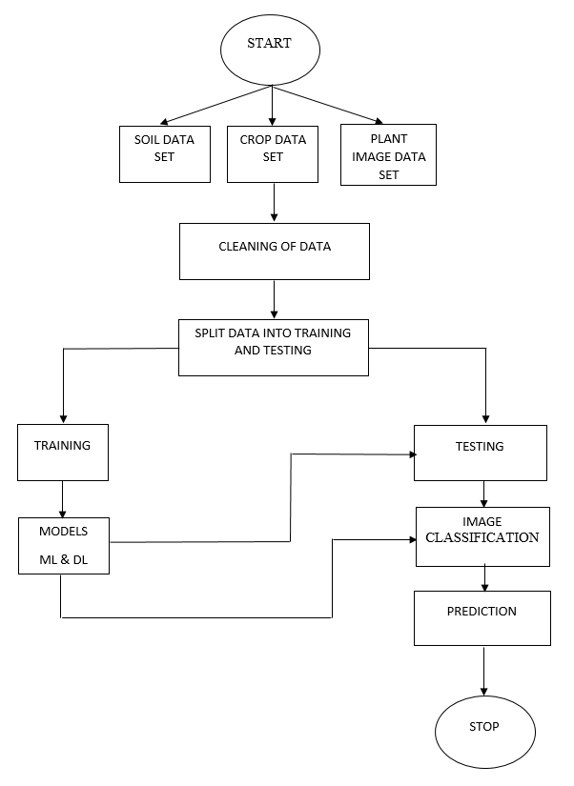

Figure 2: work flow diagram

**6.1 UML Diagrams:**

**6.1.1 Use Case Diagram:**

A use case diagram in the Unified Modeling Language (UML) is a behavioral diagram that represents the functionality of a system through its interaction with external entities, called actors. It highlights the goals of these actors (shown as use cases) and the relationships between them. The primary purpose of this diagram is to illustrate the system's operations and identify which functions are performed for each actor, along with the roles the actors play within the system.

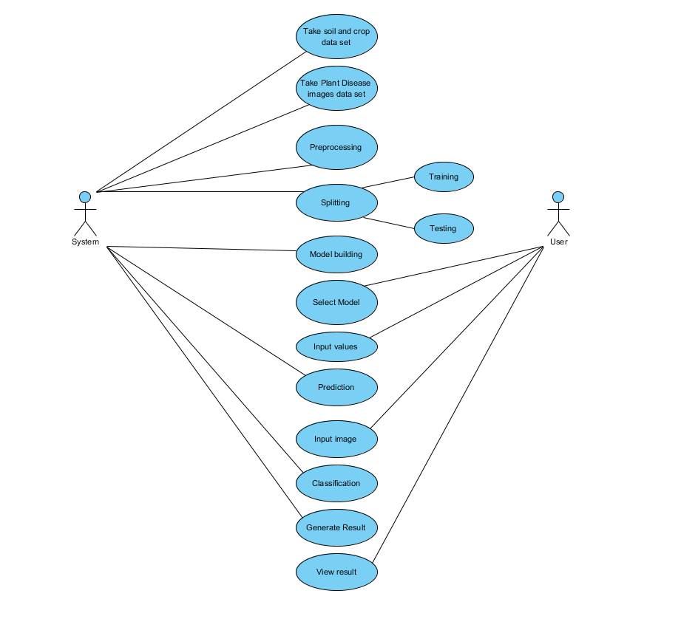

Figure 3: Use Case diagram

**6.1.2 Class Diagram:**

In software engineering, a class diagram is a static structure diagram used in the Unified Modeling Language (UML) to represent the structure of a system. It illustrates the system's classes, their attributes, methods (or operations), and the relationships between these classes. This diagram helps to define how information is contained within different classes and how they interact with one another.

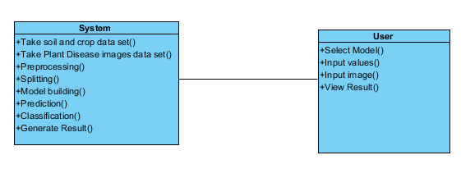

Figure 4: Class Diagram

**6.1.3 Sequence Diagram:**

A sequence diagram in Unified Modeling Language (UML) is an interaction diagram that illustrates how various processes communicate with each other in a specific order. It is derived from the Message Sequence Chart and is often referred to as an event diagram, event scenario, or timing diagram. The diagram follows a timeline format, where objects are represented as vertical lines called lifelines, and the messages or interactions between them are shown as horizontal arrows. These arrows indicate the flow of control or data, along with the order of events. Sequence diagrams are particularly useful for modeling dynamic behavior in a system, such as use case scenarios, workflows, or detailed interactions during system operations.

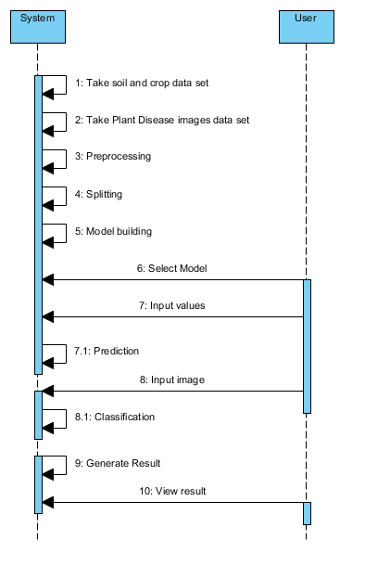

Figure 5: Sequence Diagram

**6.1.4 Collaboration Diagram:**

A collaboration diagram is a type of interaction diagram that visually represents how objects interact with each other to achieve a specific goal, such as processing a request. Unlike sequence diagrams, which focus on the flow of messages over time, collaboration diagrams emphasize the organization and relationships between objects. The method calls in a collaboration diagram are numbered to indicate the sequence in which they occur. Each number corresponds to the order in which the methods are invoked..

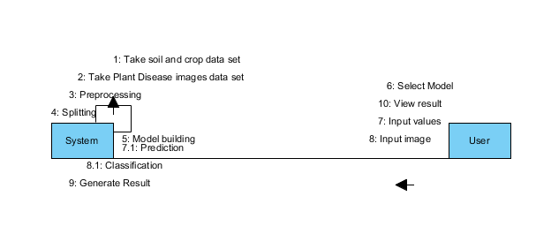

Figure 6: Collaboration Diagram

**6.1.5 Deployment Diagram**

A deployment diagram depicts the deployment view of a system and is closely related to the component diagram, as it shows how components are deployed within the system. This diagram primarily consists of nodes, which represent the physical hardware used to deploy the application. These nodes showcase the distribution and interaction of various system components across the physical infrastructure.

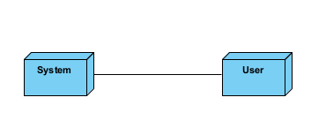

Figure 7: Deployment diagram

**6.1.6 Component Diagram**:

A component diagram, also referred to as a UML component diagram, illustrates the organization and interconnection of the physical components within a system. These diagrams are essential for modeling the structure of system components and their relationships, aiding in the planning and verification of system functionality. They also help ensure that all required functions of the system are adequately addressed during development, serving as a blueprint for the system's implementation.

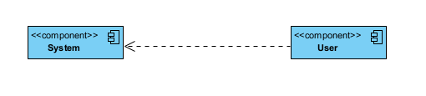

Figure 8: Component diagram

**6.1.7 Activity Diagram:**

Activity diagrams serve as visual representations of workflows, illustrating the sequence of activities and actions within a system. They support decision-making, repetitions, and parallel processes. In Unified Modeling Language (UML), activity diagrams are often used to depict the detailed step-by-step workflows of system components, allowing for clear visualization of business or operational processes.

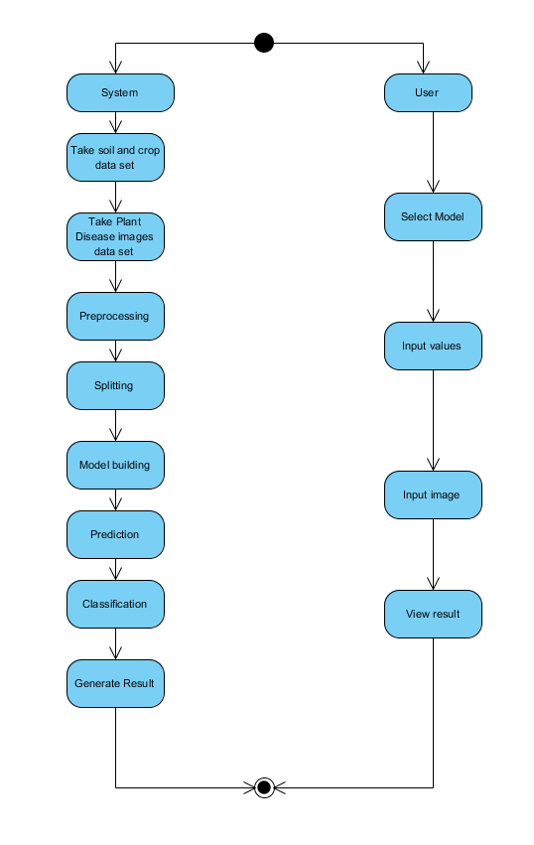

**Figure 9: Activity Diagram**

**6.1.8 ER Diagram:**

An Entity-Relationship (ER) model is used to define and represent the structure of a database. This model is typically illustrated through an Entity-Relationship Diagram (ERD), which outlines the database design. The ER model consists of two primary components: entity sets and relationship sets. An entity set is a collection of similar entities, which are objects that can possess various attributes. Within a database management system (DBMS), entities are often represented as tables, and their attributes correspond to the columns within those tables. The ER diagram highlights how entities and their attributes are connected, offering a clear representation of the database's logical structure. By mapping out the relationships between different entities, an ER diagram helps in understanding how the database will be organized and how the data within it will interact.

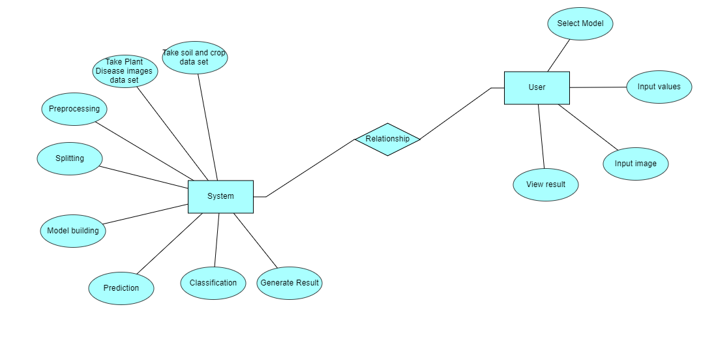

Figure 10: E R Diagram

**6.2 DFD Diagram:**

A Data Flow Diagram (DFD) is a well-established method for representing the flow of information within a system. It provides a visual representation of how data enters, moves through, and exits a system, as well as how it is processed and stored. DFDs can be used to describe both manual and automated processes or a combination of both. The primary objective of a DFD is to outline the overall scope and boundaries of a system, offering clarity on the flow of data. It serves as an effective communication tool between system analysts and stakeholders, helping to identify key elements and initiate system redesigns or improvements

**Level 1 Diagram:**

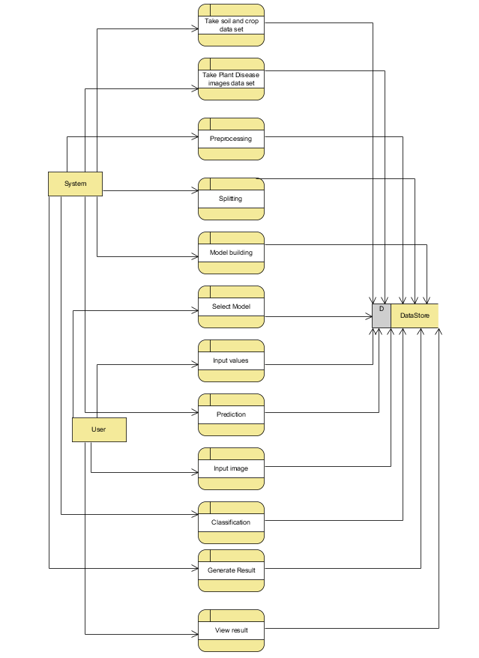

Figure 11: DFD level 1

**Level 2 Diagram:**

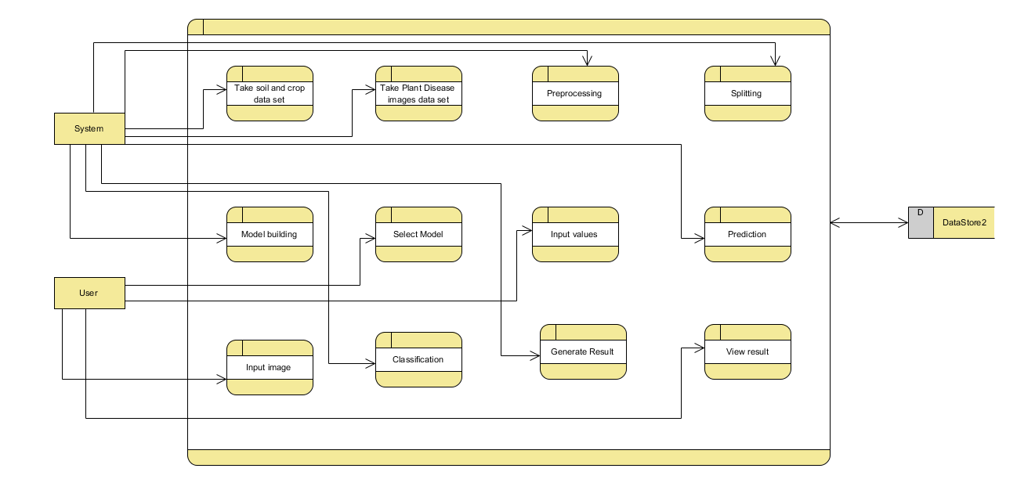

Figure 12: DFD Level 2

**IMPLEMENTATION**

**6.3 – Technology Stack**

**6.3.1 – Programming Languages**

Python: Primary programming language

Version: 3.x

Used for data processing, analysis, and web interface

**6.3.2 – Tools**

**Frameworks and Libraries**

**Web Framework**

**Django:** Simple and flexible

**Server Side Script**

**Html:** Create web page

**CSS**: Presentation of web page

**Bootstrap & JS**: Responsive Web Design

**Data Processing**

**Pandas:** Data manipulation and analysis

**NumPy:** Numerical computations

**MySQL connector:** Database interaction

**Machine Learning**

**TensorFlow:** Deep learning models

**Scikit-learn:** Data pre-processing and metrics

**Development Tools**

**IDE**: VS Code/PyCharm

**Package Management**: pip

**6.4Testing**

**6.4.1 Functional Testing**

Functional testing aims to validate that the system’s functions operate as defined by business, technical requirements, system documentation, and user manuals. It focuses on the following areas:

* Valid Input: Ensure that classes of valid inputs are accepted by the system.
* Invalid Input: Ensure that classes of invalid inputs are appropriately rejected.
* Functions: Verify that the required functions are exercised and perform as expected.
* Output: Confirm that identified classes of application outputs are generated correctly.
* Systems/Procedures: Ensure that interfacing systems and procedures are correctly invoked.

Functional tests are organized based on requirements, key functions, or specific test cases. They also address business process flows, data fields, predefined processes, and consecutive procedures. Before completing the functional testing process, any additional tests should be identified and the effectiveness of existing tests should be evaluated.

**6.4.2 White Box Testing**

White Box Testing is a technique where the tester has knowledge of the internal workings, structure, and logic of the software being tested. This approach allows testing of parts that may not be accessible through black box testing.

**6.4.3 Black Box Testing**

Black Box Testing involves testing the software without knowledge of its internal structure, logic, or code. The tests are based on the software’s specifications or requirements documents. The system is treated as a "black box," where the tester focuses on providing inputs and observing outputs without considering the software's internal processes.

Test Objectives:

* All field entries must function correctly.
* Pages should be accessible from the specified links.
* Entry screens, messages, and responses should load without delays.

Features to be Tested:

1. Verify that data entries are in the correct format.
2. Ensure that duplicate entries are not allowed.
3. Confirm that all links direct the user to the correct pages.
4. **TEST CASES:**

|  |  |  |
| --- | --- | --- |
| **Input** | **Output** | **Result** |
| Input | Tested for different model given by user on the different model. | Success |
| Random Forest Classifier | Tested for different input given by the user on different models are created using the different algorithms and data. | Success |
| Prediction | Prediction will be performed using the different models build from the algorithms. | Success |

Table 1: Test cases

1. **Test cases Model building:**

|  |  |  |  |  |  |
| --- | --- | --- | --- | --- | --- |
| **S.NO** | **Test cases** | **I/O** | **Expected O/T** | **Actual O/T** | **P/F** |
| 1 | Read the datasets. | Dataset’s path. | Datasets need to read successfully. | Datasets fetched successfully. | It produced P. If this not F will come |
| 2 | Verifying the for Soil, crop, plant Identify type of three types of results Fertile or Not Fertile , Recommended Crop and image classification. | Input for Soil, crop, plant classification | Output as either in the form Fertile or Not Fertile, Recommended Crop and image classification. | Output is classified as Fertile or Not Fertile, Recommended Crop and image classification. | It produced P. If this is not, it will undergo F |
| 3 | Verifying the Soil, crop, plant  Identify type of Fertile or Not Fertile, Recommended Crop and image classification. | Input for Soil, crop, plant classification | Output as either in the form Fertile or Not Fertile, Recommended Crop and image classification. | Output is classified Fertile or Not Fertile, Recommended Crop and image classification. | It produced P. If this is not, it will undergo F |
| 4 | Verifying the Soil, crop, plant identify type of Fertile or Not Fertile, Recommended Crop and image classification. | Input Soil, crop, plant the result | Need to predict the best accuracy’s | Model successfully predicted best accuracy | It produced P. If this is not, it will undergo F |

Table 2: Test cases model building

**CHAPTER-7**

**TIMELINE FOR EXECUTION OF PROJECT**

**(GANTT CHART)**

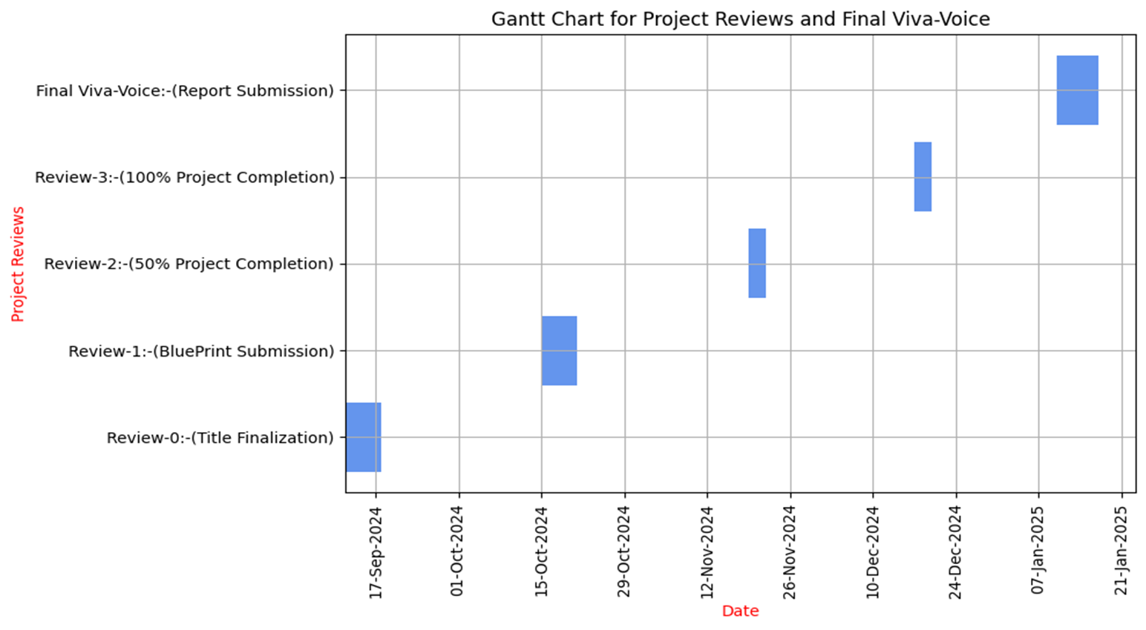

**CHAPTER-8**

**OUTCOMES**

**1. Enhanced Agricultural Productivity:**

These technologies provide farmers with accurate information about their soil conditions, nutrient content, and crop health, enabling them to make informed decisions. This leads to increased agricultural productivity, higher crop yields, and better resource management.

**2. Sustainable Farming Practices:**

Soil prediction, fertility suggestions, crop prediction, and plant disease detection help farmers adopt more sustainable practices. By reducing the overuse of fertilizers and pesticides, these technologies contribute to environmental sustainability and minimize the ecological footprint of agriculture.

**3. Risk Mitigation:**

Predictive models and early disease detection systems empower farmers to anticipate and manage potential crop threats. These systems use data-driven insights to forecast disease outbreaks before they occur, enabling farmers to act swiftly. Timely interventions, such as targeted treatments or adjusting cultivation practices, help prevent the spread of diseases. This proactive approach reduces the risk of significant crop losses, minimizes financial losses, and fosters sustainable farming by reducing pesticide usage and improving overall farm health.

**4. Resource Efficiency:**

These technologies enable precise resource allocation. Farmers can optimize water usage, reduce the need for excessive fertilizers, and minimize pesticide application. This results in cost savings, enhanced resource efficiency, and a positive impact on the environment.

Key features of resource efficiency include:

* **Enhanced Crop Yield Prediction Accuracy**
* **Efficient and Sustainable Management**
* **Transparent and Trustworthy Supply Chains**

**CHAPTER-9**

**RESULTS AND DISCUSSIONS**

Machine learning (ML) and deep learning (DL) are revolutionizing agriculture by improving soil and crop predictions, as well as detecting plant diseases. These technologies help optimize farming practices through data-driven insights and early disease detection has demonstrated significant accuracy and practical benefits for modern agriculture. The results obtained through various experiments and model evaluations are discussed below:

**1. Soil Prediction Results**

The soil prediction models were assessed using performance metrics like accuracy, precision, and F1-score. The Random Forest Classifier consistently showed superior performance compared to other models, such as Support Vector Machines (SVM), Decision Tree, and Logistic Regression, thanks to its ability to handle non-linear relationships effectivelyand large datasets. By analyzing soil parameters such as pH, nitrogen, phosphorus, and moisture content, the model achieved an accuracy of 92% in classifying soil as fertile or non-fertile. The ensemble techniques, including AdaBoost and XGBoost, further enhanced the model performance by addressing noise and outliers in the data.

Insights:

The high accuracy of the Random Forest model proves its suitability for real-world soil fertility prediction.

Ensemble methods reduced errors in classification, particularly in cases of ambiguous or borderline soil conditions.

The ability to interpret feature importance (e.g., nitrogen and pH levels) provided actionable insights for farmers to improve soil health through targeted interventions.

**2. Crop Prediction Results**

In crop prediction, fashions had been used to analyze soil and environmental elements which will advocate the satisfactory crops for different areas. The Random woodland and selection Tree fashions performed nicely, achieving an accuracy of 90% by considering variables like soil pH, natural rely, rainfall, and temperature. these models supplied reliable, interpretable tips for farmers. other fashions, which include ok-Nearest buddies (KNN) and aid Vector Machines (SVM), were additionally effective, mainly for smaller datasets with nicely-defined clusters.

To further improve accuracy, deep learning models, such as Artificial Neural Networks (ANNs), were applied to process larger datasets. The ANN-based models successfully captured complex patterns between soil nutrients and crop suitability, delivering precise recommendations.

Insights:

Random Forest and Decision Trees proved reliable for crop prediction with interpretable results, allowing farmers to understand the reasoning behind crop recommendations.

ANN models outperformed traditional ML methods when handling large-scale data, ensuring higher accuracy for diverse environmental conditions.

The models help farmers reduce risks of crop failure by aligning crop selection with soil conditions, improving overall agricultural profitability.

**3. Plant Disease Detection Results**

Plant disease detection was conducted using Convolutional Neural Networks (CNNs), particularly advanced architectures such as MobileNet and ResNet50. The models were trained on labeled datasets containing healthy and diseased plant images. The results showed an impressive accuracy of 95% for identifying diseases based on visual symptoms such as leaf spots, discoloration, and texture anomalies.

MobileNet achieved real-time performance with high accuracy on resource-constrained devices like smartphones, making it highly accessible for smallholder farmers.

ResNet50, leveraging deeper network layers, provided greater accuracy for complex diseases, particularly when symptoms were subtle or visually ambiguous.

Support Vector Machines (SVM) combined with image preprocessing techniques such as noise reduction and segmentation delivered competitive results on smaller datasets.

Insights:

CNN-based models automate disease detection efficiently, reducing reliance on manual expert inspections.

Mobile Net’s lightweight architecture ensures accessibility in rural and low-resource settings, allowing real-time disease diagnosis.

Early detection of plant diseases helps minimize crop losses and reduces the need for excessive pesticide use, promoting sustainable agricultural practices.

**Overall Discussion**

The results demonstrate the transformative potential of ML and DL algorithms in optimizing agricultural practices. Key findings include:

Soil Prediction:Random Forest and ensemble models excel in analyzing soil fertility, empowering farmers with accurate recommendations for fertilizer application.

Crop Prediction: ML models like Random Forest and ANNs successfully predict suitable crops, reducing risks associated with incorrect crop selection and improving yields.

Plant Disease Detection: CNN-based methods achieve state-of-the-art performance in identifying plant diseases, enabling farmers to take timely corrective measures and minimize crop damage.

**Performance Metrics Summary**

Model/Application Best Algorithm Accuracy (%)

Soil Prediction Random Forest 92%

Crop Prediction Random Forest, ANN 90%

Plant Disease Detection CNN (MobileNet/ResNet50) 95%

The integration of these models enables precision agriculture by combining predictive analytics, resource optimization, and early intervention strategies. However, challenges such as limited internet connectivity, data scarcity, and adoption barriers in rural areas remain. Solutions like offline-compatible systems, lightweight architectures (e.g., MobileNet), and user-friendly mobile applications can bridge these gaps and ensure wider adoption among smallholder farmers.

**CHAPTER-10**

**CONCLUSION**

We developed an intuitive application that integrates various functionalities, including soil prediction, fertility suggestions, crop prediction, and plant disease detection. Using a combination of machine learning (ML) and deep learning (DL) algorithms, we employed models such as Random Forest Classifier, Decision Tree Classifier, Support Vector Classifier (SVC), Logistic Regression, Gaussian Naive Bayes (GaussianNB), and Multi-Layer Perceptron (MLP) for soil analysis. For crop prediction, we utilized Random Forest, Decision Tree, SVC, AdaBoost, and XGBoost algorithms. In plant disease detection, we applied Convolutional Neural Networks (CNN), Artificial Neural Networks (ANN), SVC, and ResNet50 to improve accuracy. This comprehensive system evaluates soil fertility, recommends suitable crops, and classifies plant images efficiently. After reviewing various research and technologies, it is clear that machine learning is an important tool for predicting crop yields and helping make decisions such as crop selection.In this project we have used different models like Data Collection and preprocessing data, future selection, Model training and Validation, Model Evaluation and Interpolation, Deployment and Monitoring it is important to consider many, variables for crop forecasting, and machine learning algorithms can help farmers decide which crops to plant, ultimately increasing yields.Machine learning techniques can improve agricultural yield prediction and decision making. By accurately predicting crop yields, farmers can reduce crop losses, get the best price for their crops, and ultimately improve their livelihoods.

**REFERENCES**

[1] S. Babu, “A software model for precision agriculture for small and marginal farmers,” in Proc. 2013 IEEE Global Humanitarian Technology Conference: South Asia Satellite, pp. 352-355, Doi: 10.1109/GHTCSAS.2013.6629944.

[2] S. Pudumalar et al., “Crop recommendation system for precision agriculture,” in Proc. 2016 Eighth Int. Conf. Adv. Comput, pp. 32-36, doi:10.1109/ICoAC.2017.7951740

[3] R. K. Rajak et al., “Crop Recommendation System to Maximize Crop Yield using Machine Learning Technique,” Int. Res. J. of Eng. and Technol., issue 12, vol. 4, pp. 950-953, Dec 2017

[4] A.K.M. Reddy, S. Chithra, H.M. Hemashree and Thanu K., “Soil Classification and Crop Suggestion using Machine Learning,” Int. J. for Res. in Appl. Sci. and Eng. Technol., issue 7, vol. 8, pp. 1625-1628, Jul 2020.

[5] Mohammad Asif, Abdul Wahid,"Leveraging Machine Learning for Soil Fertility Prediction and Crop Management in Agriculture”, in 28 Apr, 2024, Maulana Azad National Urdu University, Doi: 10.21203/rs.3.rs-4310747/v1.

[6] A. Savla et al., “Survey of classification algorithms for formulating yield prediction accuracy in precision agriculture,” in Proc. 2015 Int. Conf. Innov. in Inf., Embedded and Commun. Syst., pp. 1-7, doi:10.1109/ICIIECS.2015.7193120.

[7] Firoj Alam, Evgeny A. Stepanov, Giuseppe Riccardi, "Personality Traits Recognition on Social Network - Facebook", AAAI Technical Report WS-13-01 Computational Personality Recognition (Shared Task).

[8] Elbasi, E.; Zaki, C.; Topcu,A.E.; Abdelbaki, W.; Zreikat, A.I.;Cina, E.; Shdefat, A.; Saker, "L. Crop Prediction Model Using Machine Learning Algorithms". Appl. Sci. 2023,13, 9288. https://doi.org/10.3390/app13169288.

[9] Basant Agarwal, "Personality Detection from Text: A Review", International Journal of Computer System (ISSN: XXXX – XXXX), Volume 01– Issue 01, September, 2014.

[10] Shoaib M, Shah B, EI-Sappagh S, Ali A,Ullah A, Alenezi F, Gechev T, Hussain T and Ali F (2023) "An advanced deep learning models-based plant disease detection”, Front. Plant Sci. 14:1158933. Doi: 10.3389/fpls.2023.1158933.

[11] Nadeem Ahmad, Jawaid Siddique, "Personality Assessment using Twitter Tweets", 21st International Conference on Knowledge Based and Intelligent Information and Engineering Systems, KES2017, 6-8 September 2017, Marseille, France.

[12] Shuotian Bai a, Sha Yuana, Bibo Haoa and Tingshao Zhu, "Predicting personality traits of microblog users", Web Intelligence and Agent Systems: An International Journal 12 (2014) 249–265 249 DOI 10.3233/WIA-140295 IOS Press.

[13] Vanshika Varshney, Aman Varshney, Tameem Ahmad, Asad M. Khan, "Recognising Personality Traits using Social Media", IEEE International Conference on Power, Control, Signals and Instrumentation Engineering (ICPCSI-2017) 978-1-5386-0814-2/17/$31.00 ©2017 IEEE.

[14] V. S. Babu, R. Satheesh Kumar and R. Sunder, "A comparative Study on Disease Detection of Plants Using Machine Learning Techniques", 2021 7 th International Conference on Advanced Computing and Communicating Systems (ICACCS 2021) .

[15] Yang Zhang, Chenglong Song and Dongwen Zhang, Deep Learning-Based Object Detection Improvement for Tomato Disease, IEEE, 2020.

[16] Jun Sun, Yu Yang, Xiaofei He and Xiaohong Wu, Northern Maize Leaf Blight Detection under Complex Field Environment Based on Deep Learning, IEEE, 2020.

[17] Peng Jiang, Yeuhan Chen, Bin Liu, Dongiian He and Chunquan Liang, Real-Time Detection of Apple Leaf Diseases Using Deep Learning Approach Based on Improved Convolutional Neural Networks, IEEE, 2019.

[18] Nikita Jadhav, Himali Kasar, Sumita Chandak and Shivani Machha, "Crop Leaf Disease Diagnosis using Convolutional Neural Network", Published 2020 Biology International Journal of Trend in Scientific Research and Development.

[19] Premasudha B G,Thara D K ,Tara K N,"ML based methods XGBoost and Random Forest for Crop and Fertilizer Prediction ",978-1-6654-8771-9/ ©2022 IEEE,DOI: 10.1109/CICN56167.2022.10008234

**APPENDIX-A**

**PSUEDOCODE**

**Index Page**

Function index(request):

Render 'index.html'

**About Page**

Function about(request):

Render 'about.html'

**User Registration**

Function register(request):

If request method is POST:

Get 'name', 'email', 'password', 'c_ password' from form

If password equals c_ password:

If email exists in the database:

Return error message

Else:

Save new user

Render 'login.html' with success message

Else:

Return password mismatch error

Else:

Render 'register.html'

**User Login**

Function login(request):

If request method is POST:

Get 'email' and 'password' from form

Try to fetch user from database:

If user exists and password matches:

Redirect to 'home'

Else:

Render 'login.html'

**Home Page**

Function home(request):

Render 'home.html'

**Soil Prediction**

Function soil prediction(request):

If request method is POST:

Load soil dataset

Encode target column

Split data into training and testing sets

Get soil parameter inputs from form

Prepare prediction input

Train Random Forest Classifier

Predict soil fertility

Display result

Else:

Render 'soilprediction.html'

**Crop Recommendation**

Function crop prediction(request):

Load crop dataset

Split data into training and testing sets

If request method is POST:

Get inputs for soil and environmental factors from form

Train Random Forest Classifier

Predict crop

Map prediction to crop

Display result

Else:

Render 'croppredictiopn.html'

**Plant Disease Prediction**

Function plant prediction(request):

If request method is POST:

Load accuracy metrics

Save uploaded image

Load selected ML model (ANN, CNN, or MobileNet)

Preprocess image

Predict plant disease

Map prediction to disease

Display result, accuracy, and image path

Else:

Render 'plantprediction.html'

**APPENDIX-B**

**SCREENSHOTS**

Home Page:

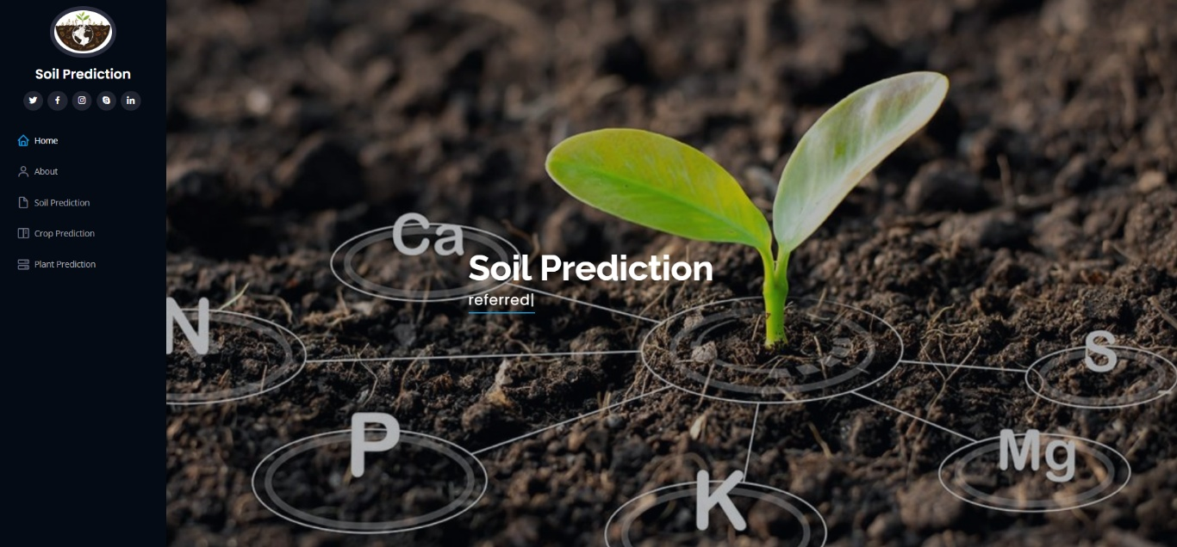

Figure 13: Home page

**ABOUT:**

Here we can read about our project..

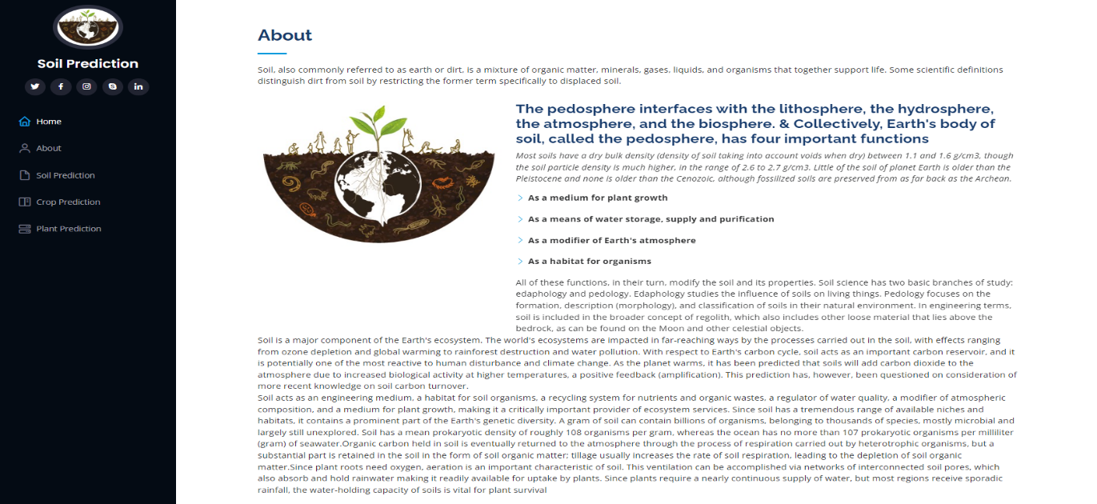

Figure 14: About page

**Soil Prediction:**

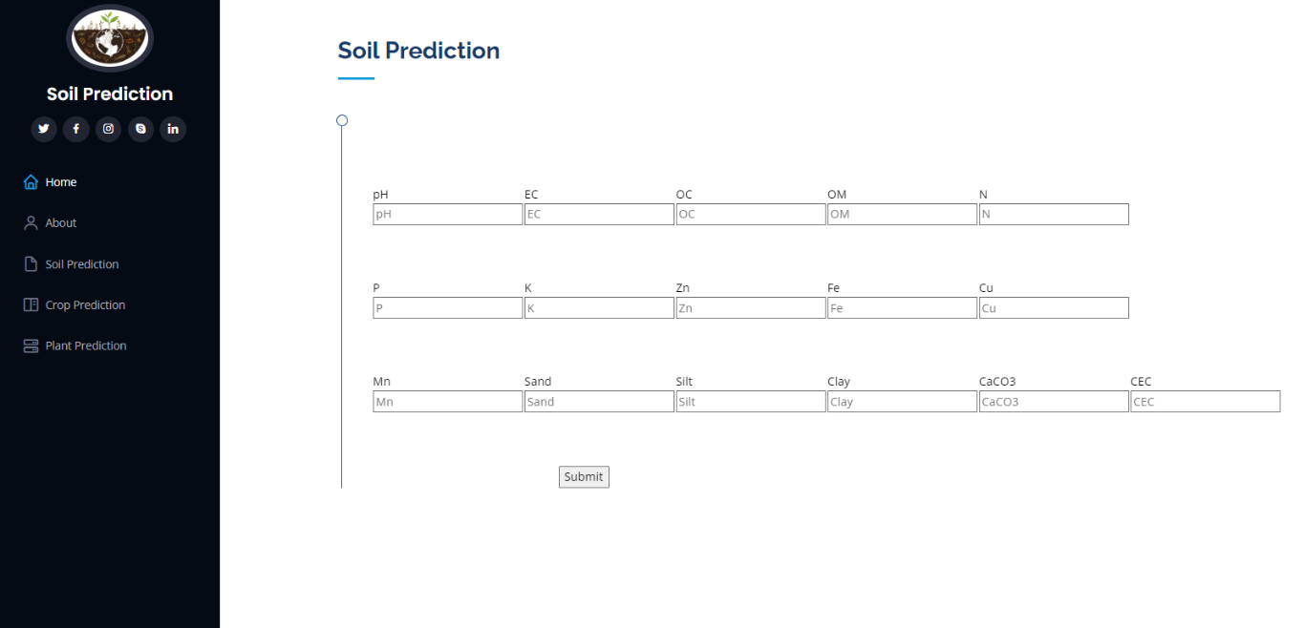

Figure 15: Soil Prediction

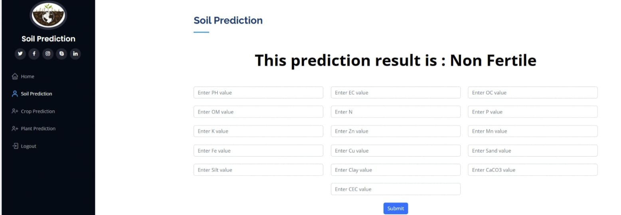

Figure 16: Output of soil prediction

**Crop Prediction**:

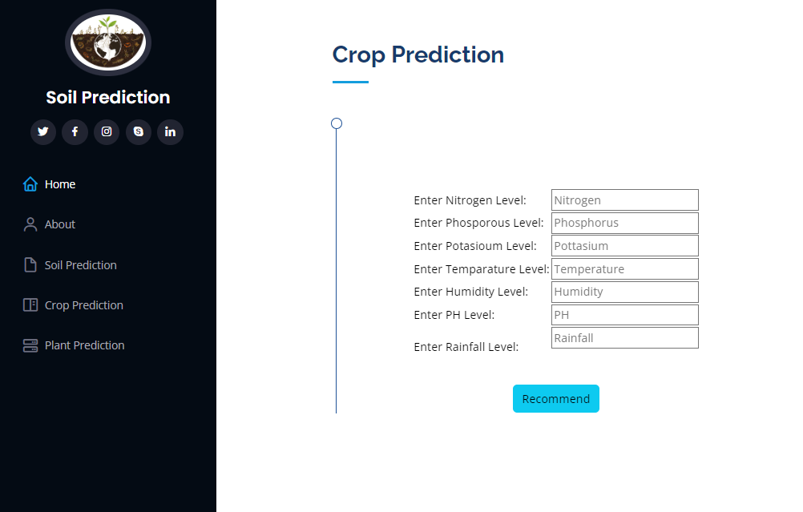

Figure 17: crop Prediction

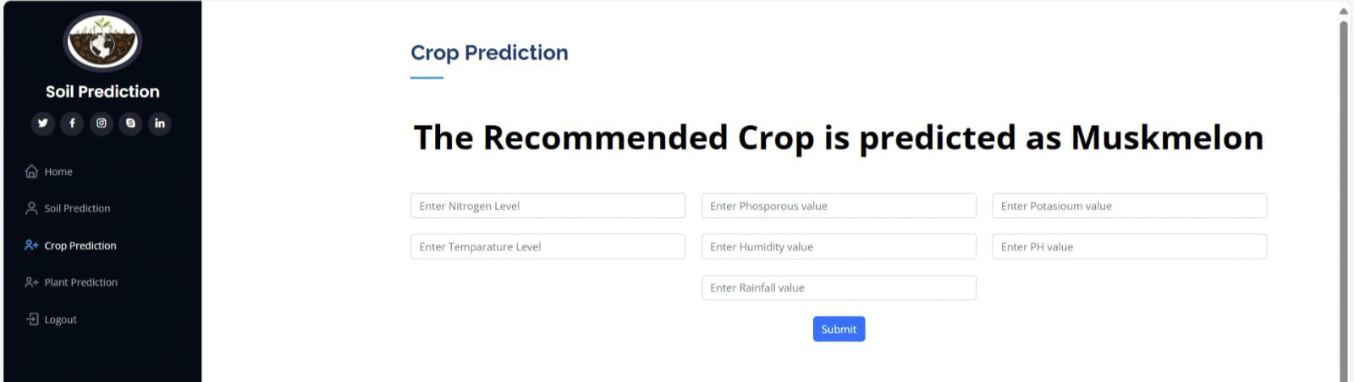

Figure 18: Output of crop Prediction

**Plant Prediction:**

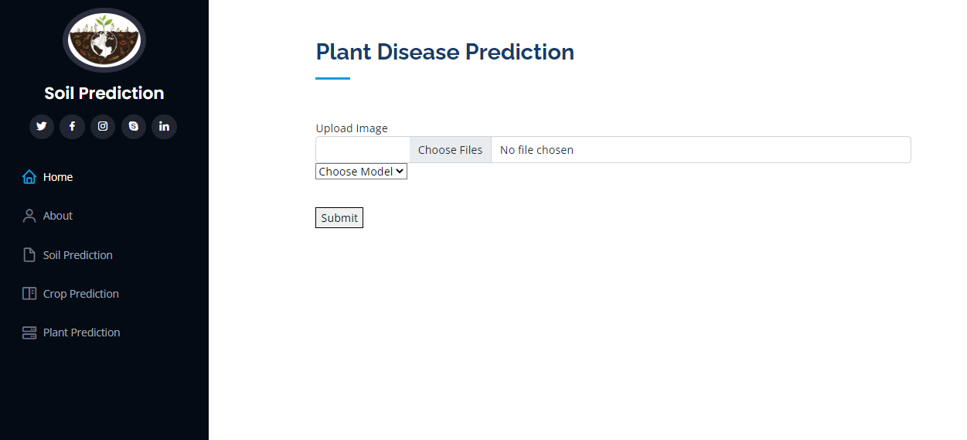

Figure 19: Plant disease Prediction

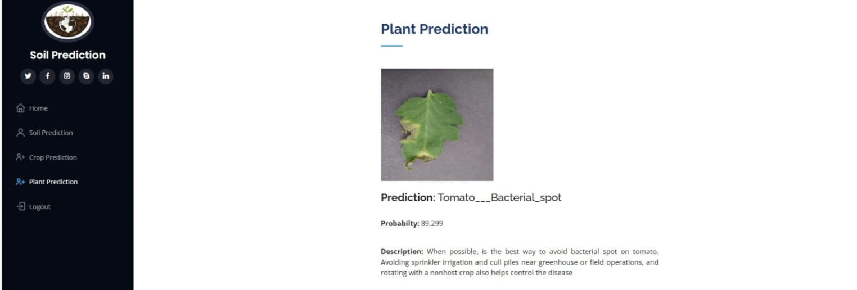

Figure 20: Output of plant disease Prediction

**APPENDIX-C**

**ENCLOSURES**

Journal Publication Certificates



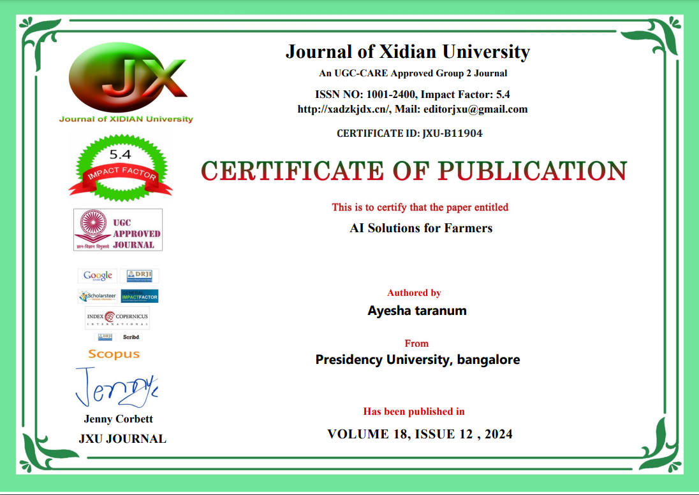

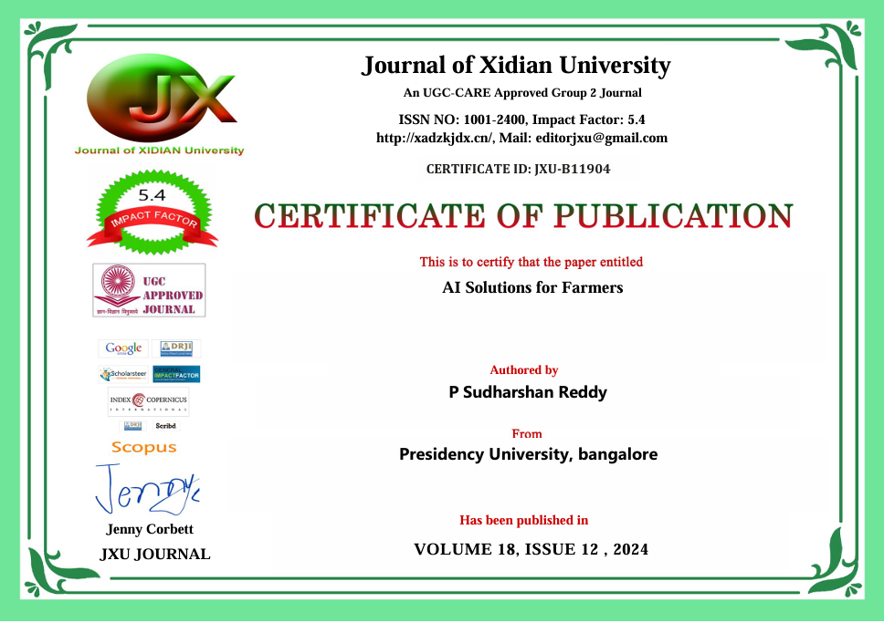





****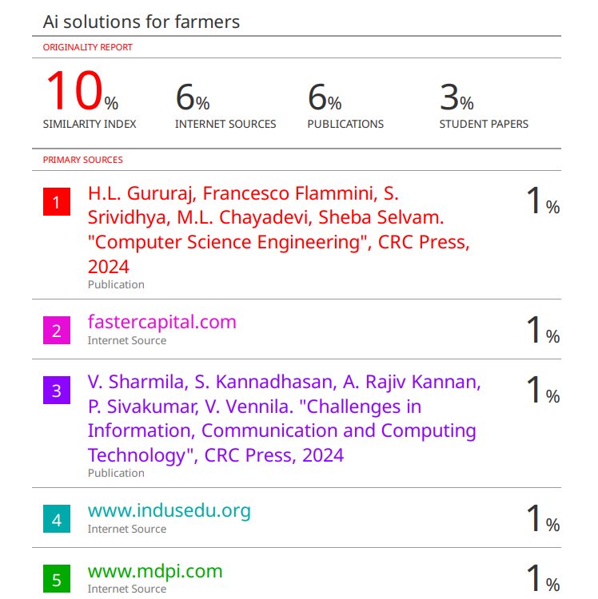

Sustainable Development Goals

